**STEP1:**

Edit linker settings

In codeblocks ide

Settings => compiler => linker settings => add => ws2_32 => ok

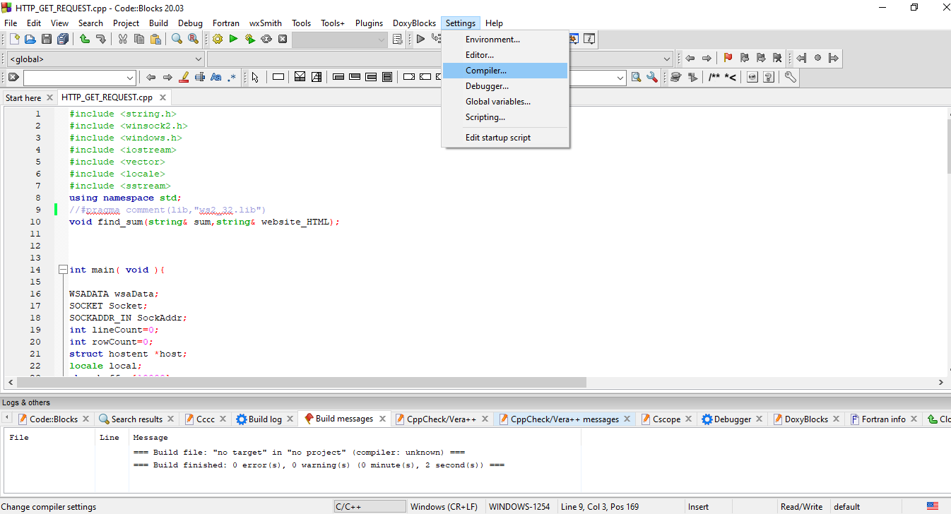

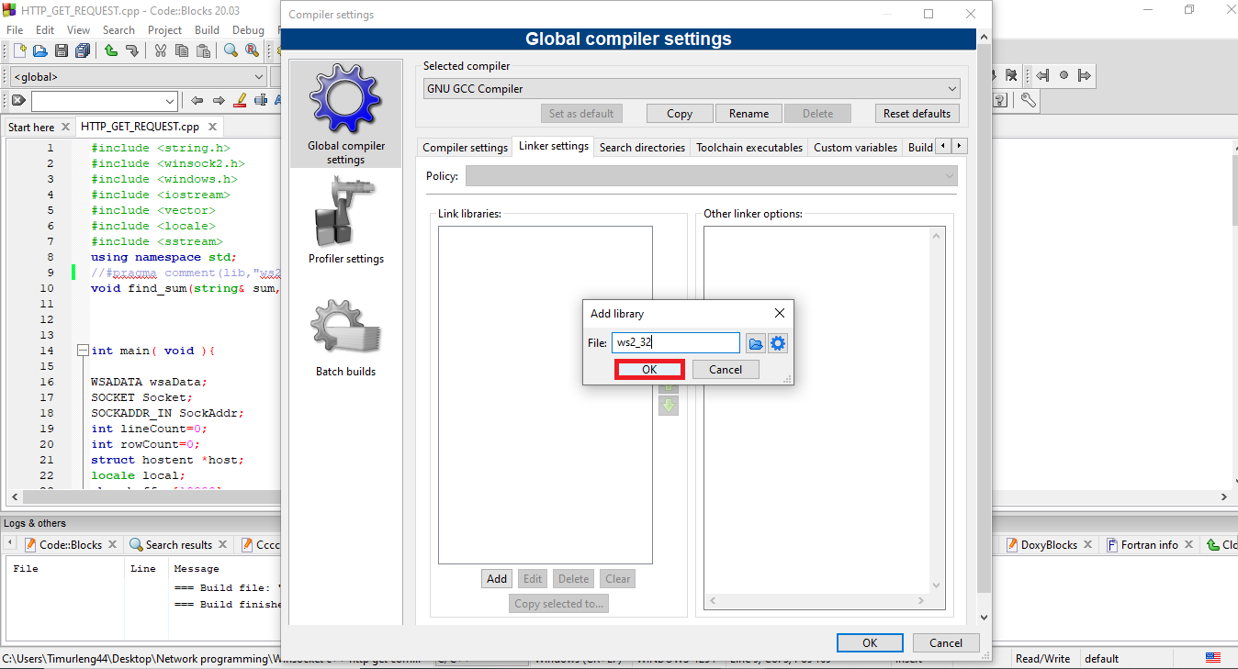

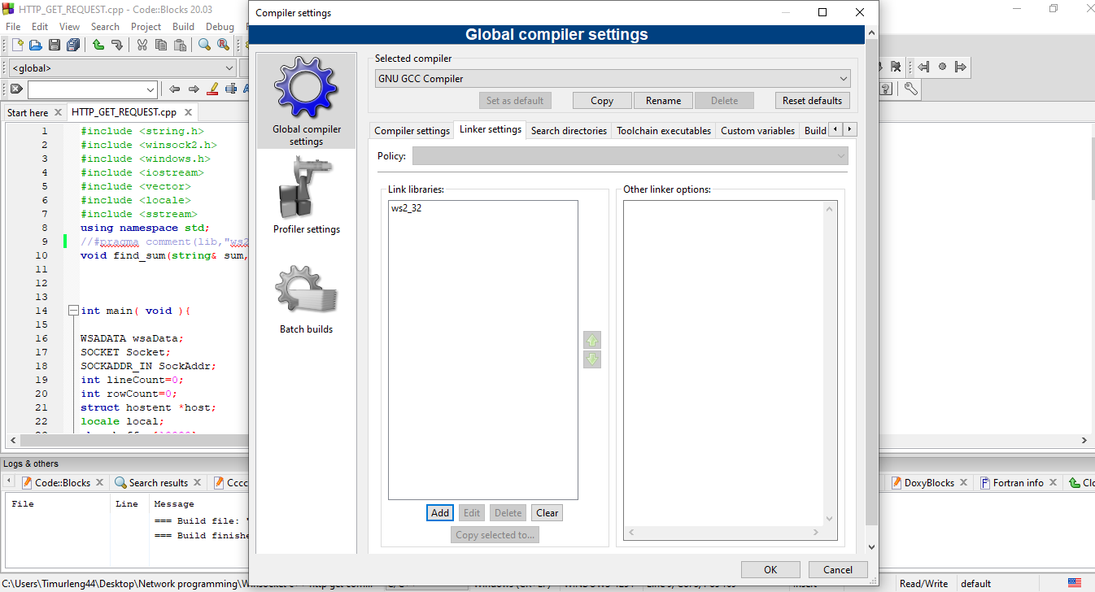

In DevC++

Tools => Compiler Options => -lws2_32

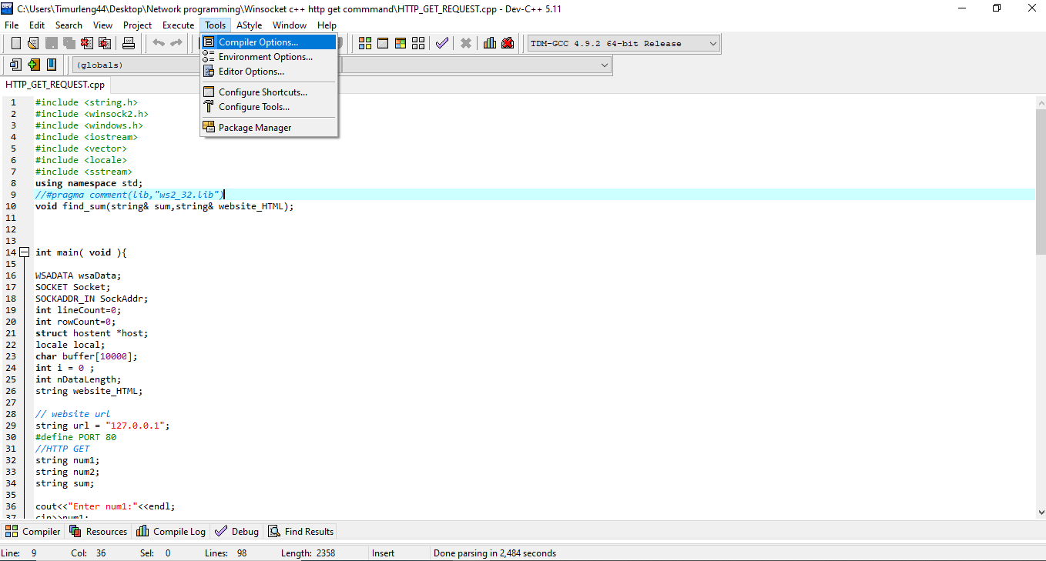

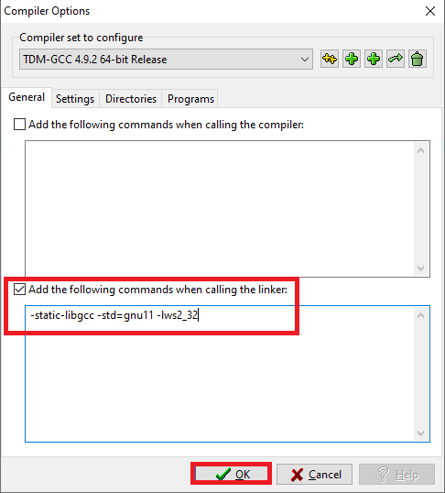

**STEP 2:**

Go to: This PC => xampp => htdocs

C:\xampp\htdocs

Create a new folder

And rename as sum

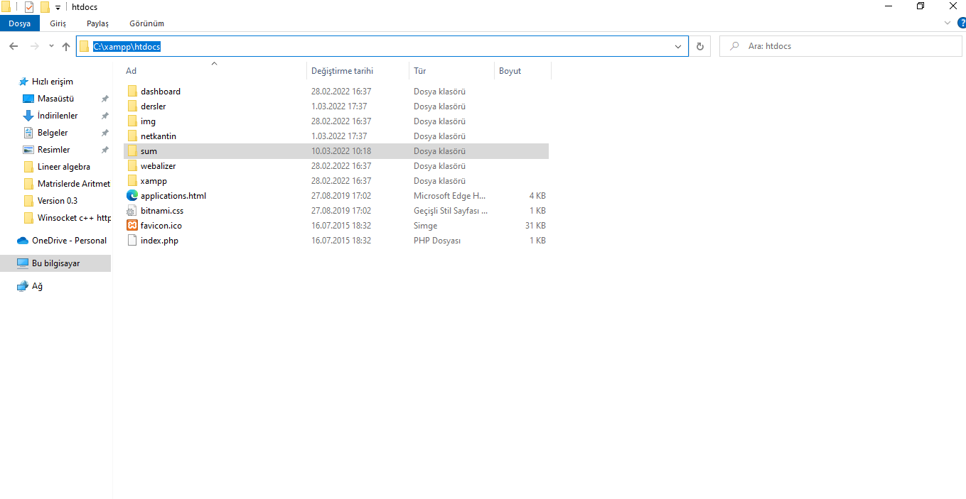

Open the sum folder

Put index.php file into the sum file

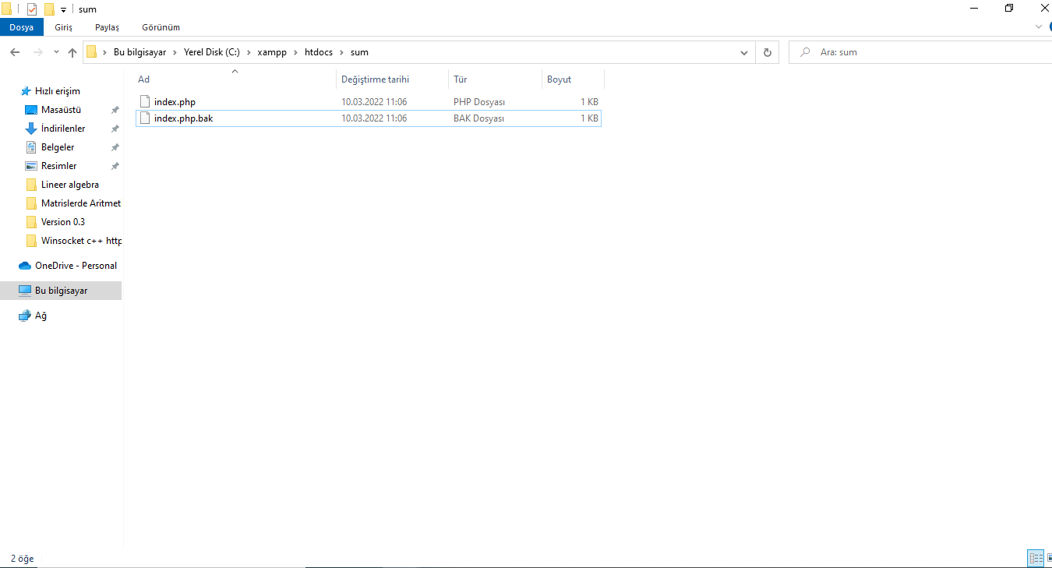

**STEP 3:**

Open XAMPP CONTROL PANEL and start Apache

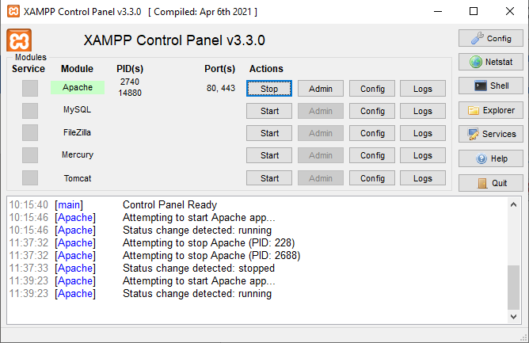

You can check php is work or not on browser.

Write to url

127.0.0.1:80/sum/?num1=55&num2=99

or

127.0.0.1:443/sum/?num1=55&num2=99

and hit enter



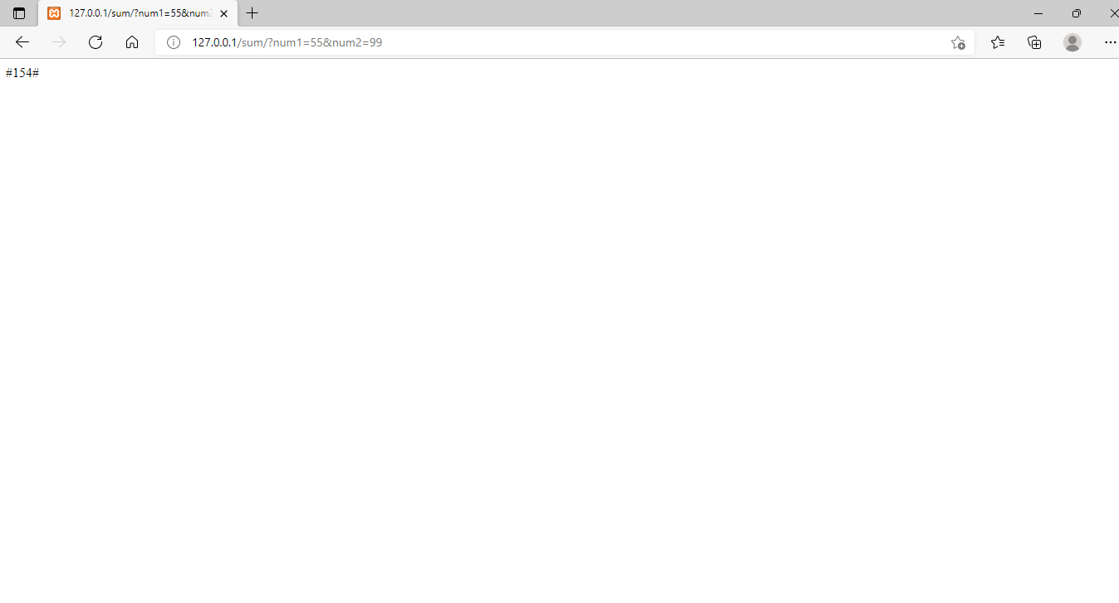

**Step 4:**

compile cpp file and run it 